24.72: This situation is analagous to having two capacitors in parallel, each with an area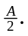So:
